**TABLE OF CONTENT**

Declaration I

Project Approval Sheet II

Certificate III

Acknowledgement IV

Abstract V

List of Figures VI

**CHAPTER 1 –** **INTRODUCTION** **3-5**

* 1. Introduction 3
  2. Problem statement 3
  3. Need for proper system 3
  4. Objective 4
  5. Modules of system 4
  6. Scope 5

**CHAPTER 2 –** **LITERATURE SURVEY 6-8**

2.1. Existing Systems 6

2.2. Proposed Systems 7

2.3. Feasibility Study 7

2.3.1 Technical Feasibility 7

2.3.2 Economic Feasibility 7

2.3.3 Operational Feasibility 8

**CHAPTER 3 –** **REQUIREMENT ANALYSIS 9-10**

3.1 Method used for requirement analysis 9

3.2 Data Requirements 9

3.3 Functional Requirements 9

3.4 Non-Functional Requirements 10

3.5 System Specifications 10

3.5.1 Hardware Specifications 10

3.5.2 Software Specifications 10

**CHAPTER 4 –** **DESIGN 11-15**

* 1. Software Requirement Specifications 11
     1. Supplementary Specifications 11
     2. Use Case Models 12
  2. Conceptual level class Diagram 13
  3. Conceptual level activity diagram 14
  4. Data flow diagram (Level 0,1,2) 15

**CHAPTER 5 –** **SYSTEM MODELING 16-19**

5.1 Detailed Class Diagram 16

5.2 Admin Class Diagram 17

5.3 Interaction Diagram 18

5.3.1 Sequence Diagram 18

5.4 Object Diagram 19

**TABLE OF FIGURE CONTENT**

1. Use Case Model 12
2. Conceptional Level Class diagram
   1. User Class Diagram 13
   2. Authority Class Diagram 14
   3. Admin Class Diagram 14
3. Conceptional Level Activity Diagram 15
4. Data Flow Diagram 16
5. Detailed Class Diagram 17
6. Admin Class Diagram 18
7. Interaction Diagram
   1. Sequence Diagram User
   2. Sequence Diagram Authority
   3. Sequence Diagram Admin
8. Activity Diagram

**CHAPTER-1: INTRODUCTION**

* 1. **Introduction**

This project on the topic on generating and maintaining E-Pass. It is a web-based technology that will manage the record of pass which is issued by higher authorities in the situation of pandemic.

This application will help in providing passes to the needy persons to go out for any type of emergency, whether they want to go to hospital or any other important work and also facilitate to supply on-line curfew e-pass to those who got to travel mandatory. This application will generate token id for individuals and it is unique for everyone. By showing Passes which have this id user can go out.Person has to get permit from higher authorities and for getting permit the reason should be valid, only those persons which have valid reason can get the permission.

It also improves efficiency and effectiveness by minimizing the amount of physical labour required. The software is intended to deliver accurate and reliable data.

The code powered by Python using Django (framework of python). This easy-to-operate system helps to access and modify user details, provides economical printing facility.And we also provide QR code on E-pass.

* 1. **Problem Statement**

As we saw in the pandemic situation, only few people who are authorized to go in the public places and under unusual circumstances, people may need to go from one town to another in case of any medical emergency and in regulate the movement of goods and there have been instances where delivery agents from companies such as Med life as well as vegetable vendors have been beaten up while they were trying to go about their duties. This problem arose when people tried to by-pass this law, and crowded the places and broke the laws made by government and this may increase the spread of infection among people.

* 1. **Need for the proper System**

This Curfew E-pass system guarantee to provide services during the COVID-19 pandemic, valid passes must be obtained as quickly as feasible.

There is a need to get valid passes as efficiently as possible to ensure essential services keep functioning during Covid-19 Pandemic.

This mechanism will aid in people's contact-less transportation. The electronic version of the paper gate pass is available.

This system is a web-based solution that not only keeps the huge crowd away but also helps the administration in implementing social distancing.

* 1. **Objective**

The goal or objective of the project “Curfew E Pass Management System’’ is to develop a System that can be utilized during curfew to efficiently manage people’s passes during Covid-19.

In this website the database can hold data and instruction in an electronic representation in internal memory and this data can be retrieved at any time.

The main purpose is to build up a framework that can automate the processes and task of travel service in a simple way.

* 1. **Modules of the System**

Home Page: - Home page consisting of some text and pictures which explains all the working of how the pass is process behind and which authority is passing the pass.

Login Page: - Login page is consisting fields like phone number and password.

Register Page: - Register page consist of Name of user, phone number of user, email id of user and password. After enter of phone number user should valid the phone number by OTP and after that user should have to validate the email ID by again OTP and then user can Register finally.

User Dashboard: -

1. Apply for a New Pass: - User can apply for a new pass. For applying a new pass user have to fill some other details like: Name, Date of Birth, Phone Number, email ID, Photo Address, Reason of applying pass, Date from Start and Date till he wants that pass, Starting location, End Location. There are 3 types of users

* Government Employee
* Medical Staff
* Normal User/ General Category

User should also select the parameter in which they lie. If they are government employee or medial staff, they need to upload their ID.

1. Renew Pass: - for renew the pass they can apply directly same as old pass or can update the pass before apply. For update pass they need to change dates or locations if any possible.
2. Update Pass: - Users that want to update their locations, phone number or email id and then apply for pass again.
3. History: - If the user is new then there is no history of passes and if it was an old user then we will be showing all the past apply pass history and also the status of pass like valid, pending, expired.

Admin Panel: - (Authority like police or anyone else person that can give confirmation of that person)

1. Review Requests: - Admin can review the requests and also check their history of previous passes. Also, can accept or decline the pass. The pass request consists of all the details of the user like name, picture and other data.

Super Admin: -

1. Handle request: - Super admin can check request and pass to the admin or authority to get confirmation. Check status of all the request of all panels.
2. Handle user: - Super admin can check how many peoples having the pass.

Pass Format: - pass consist of name of user, phone number, email, picture and QR code.

Function of QR code: - whenever any person can scan a QR code they can see the details of user like

Name, number, email, start date, end date, start location, end location, address, picture, etc.

Function from Admin: -

After confirmation of pass from admin panel we target a mail to the user with the pdf of pass format and QR code so that they don’t need to print the pass.

* 1. **Scope**

You can use curfew e-passes not only in covid situation but also in the situation of riots or any other critical situation like disaster etc.

Once you request for your e-pass and all of your credentials are stuffed and your purpose has been clearly expressed, your application is sent to the authorities for examination. The assigned department can then notify you via associate degree SMS if your application has been approved. The SMS will offer a transfer link to induce the e-pass.

This e-pass has to be carried with you when, you want are out of your movement area, and if you are stopped be personnel to see your details, then you will be permissible to travel throughout the imprisonment.

**CHAPTER-2: LITERATURE SURVEY**

* 1. **Existing System**

**Lockdown E-Pass management System**

Lockdown E-Pass management System is a Web-based application. This system is user friendly and easy to handle. This application has access to manage the records of pass which are issued by administrator. This Lockdown E-Pass Management System is implemented by using PHP and MySQL database. This system Lockdown E-Pass Management System is implemented to simplify the task and reduce the paperwork. This system replaces the previous method of giving paper passes. These kinds of systems are beneficial to increase efficiency by reducing manual work.

This Lockdown E-Pass Management System has admin panel which has different features. One of the sections in system is Category. Admin can add categories in this section. Also, these categories can be updated by admin if needed.  Another important section is E-pass management section. In this section admin will be able add E-pass, this add E-pass form will have important fields like contact information, identity type, identity card no., etc. and also this E-pass information can be updated if needed. These E-pass details can be viewed by admin and can be printed if needed.

**e-Pass Management System in Uttar Pradesh**

NIC has developed a centralized e-Pass Management System for the pass seekers in different districts of the state during the lockdown owing to Corona Virus pandemic. The e-Pass system is a web-based solution that not only keeps the huge crowds away from the district collectorate offices but also helps the administration in implementing social distancing as advocated by the Health Ministry and other experts.

NIC UPSC took up the initiative and developed a fully functional system for receiving online pass request from organizations, individuals and businesses for issuing passes to multiple entities for movement within the district and across the districts to provide essential services in the State. The e-Pass system is hosted on web and captures 22 categories of essential services such as health care, ration shop, food supply through e-commerce, telecom, postal, banking, etc. The district administration officials such as Additional District Magistrates (ADM) and Sub District Magistrates (SDM) are nominated as e-Pass issuing authorities in the district, but their identities are not visible to the applicant for security reasons. Applicant can apply for pass from home or mobile using internet with OTP based confirmation. The application is automatically forwarded to the ADM of SDM depending on the location and movement details. All the applications will appear on the dashboard of respective issuing authorities for approval and rejection of the passes. After scrutiny of the information and documents uploaded by applicants, issuing authorities gives approval on the portal, after approval a link is sent to the applicant mobile number through SMS which consists of pass details that can be downloaded with issuing authority signature on the pass.

* 1. **Proposed System**

We propose a system which provides user the option to get the e-pass after successful login. We will use an authentication system to authenticate the user. All this will happen on a web application and thus none of the user is expected to have a desktop or any other major specific requirement to operate our system. Everyone one can run the application and can easily get an e-pass. System posses a web application, where we ask user to submit their Name, Email Id, Contact Number, Photograph, Date of Birth, Address after that user can request for e-pass.

If the user gets validated by the higher authority, then the user can use the e-pass otherwise he/she may need to send request again. All this will happen on a simple web app and that too free of cost.

* 1. **Feasibility Study**

Here, we will carry out a study to gain an understanding of the customer’s current system and problems experienced in this system through observations, and participations. We will use the obtained data to determine the viability of the system being proposed in terms of technical, economical and operational feasibility.

* + 1. **Technical Feasibility**

Project **Curfew E-Pass Management System** is a complete web-based application. The main technologies and tools that are associated with project are:

* Database: MySQL
* Server: Apache
* Frontend: HTML, CSS, Bootstrap
* Scripting language: Java Script
* IDE: Visual studio code
* Technology: Python, Django
* Data Drawing Tools:
* Draw.io

Each of the technologies are freely available and the technical skills required are manageable. Time limitations of the product development and the ease of implementing using these technologies are synchronized.

Initially the web site will be hosted in a free web hosting space, but for later implementing it will be hosted in paid web hosting space with a sufficient bandwidth. Bandwidth required in this application is very low, since it doesn’t incorporate any multimedia aspect.

* + 1. **Economic Feasibility**
* Development Cost
* Equipment’s required for developing the software are easily available.
* Equipment maintenance is also minimum.
* Saving of paperwork and manpower reduced.
* Benefits which cannot be measured
* Visitor doesn’t have to spend much time.
* Increased satisfaction of visitor.
  + 1. **Operational Feasibility**

Proposed system is beneficial only if it can be turned into system that will meet the need of the clients operating requirement.

The proposed system is operationally feasible due to the following reasons:

* The System is easy to use and is very simple.
* The proposed system will cost no harm to the other software; instead, it will enhance the result in a better respect.

The new system will avoid confusion and resistance by catching the user’s attention, as it is presentable.

**CHAPTER-3: REQUIREMENTS ANALYSIS**

* 1. **Method used for Requirement analysis**

After gathering all the information about the application now we have a knowledge of past implemented applications that is similar but not as our product. For requirements analysis, we learn about the past implemented systems and understand the working flow. We also try to communicate with the audience to get what an end-user wants and its requirements form our application. There are some areas in which you need a pass with a time limit where we can use our application. Governments of different countries can also use this application in Curfew, Licenses and other works as well.

* 1. **Data Requirements**

We need different types of data from end user side and also, we need some data of authorities that works to authorize the pass for any user. As well as we need the data of user that handles all the data of user and authorize.

1. **Authorities’ data:**

* Letter from government to grant permissions.
* Information of members working to grant permissions (Name, IDs, Mobile Number, Email ID, Department Name).

1. **User:**

* We need user personal data like Name, Email Id, Contact Number, Photograph, Date of Birth, Address.
* User also need to verify their details by OTP so for confirming of data of user primary key is OTP on both Mobile number and Email ID.

1. **Admin Details:**

* There is only one admin to control the overall flow of data like confirming the requests from user end and transfer request to the authorities for further process.
  1. **Functional Requirements**

We have different levels of functional requirements in the complete flow of application:

* User Authentication.
* User Registration.
* Data Validation using OTP on Email and Number.
* Accepting Request of user.
* Transfer the request to the department.
* Accept or reject the request from department.
* Update profile information.
  1. **Non-Functional Requirements**

The curfew pass application has different types of non-functional requirements for user, authorities and Admin.

1. **User**

* Dashboard having Multiple options related to pass.
* Apply for new pass or update the current pass.
* See history of applied passes.
* Profile to see his filled data.

1. **Authorities**

* Check all the new and old requests.
* Confirmed users and rejected user.

1. **Admin**

* Check the new requests.
* Check the status of requests from authorities.
  1. **System Specification**
     1. **Hardware specification**
* Processor:Intel P-IV based system and above
* Processor Speed:2.0. GHz and above
* RAM:2 GB minimum
* Hard Disk: 40GB to 80GB free
  + 1. **Software Specifications**
* Database: MySQL
* Server: Apache
* Frontend: HTML, CSS, Bootstrap
* Scripting language: Java Script
* IDE: Visual studio code
* Technology: Python, Django

**CHAPTER-4: DESIGN**

* 1. **Software Requirements Specifications**

Software Requirement Specification (SRS) Format as name suggests, is complete specification and description of requirements of software that needs to be fulfilled for successful development of software system. These requirements can be functional as well as non-requirements depending upon type of requirement.

* + 1. **Supplementary Specifications**

**Functionality:**

* User can apply for an e-pass.
* User can apply to update the pass when meeting certain conditions.
* User can update his/her own information shared with the application.0
* User can view and download the e-pass from the web-application.
* User will get a mail for the accepted pass request which will include the pass details.

**Usability:**

The proposed systems easy to use for user.

**Scalability:**

E-Pass management system can be implemented on a larger scale when needed.

**Windows Compliance:**

The desktop user-interface shall be windows 95/98 compliant.

**Design for Ease-of-User:**

The user interface of the E-Pass Management System is designed for ease-of-use and shall be appropriate for a computer-literate user community with no additional training on the System.

**Reliability:**

This section lists all reliability requirements.

**Availability:**

The E-Pass management system shall be available 24 hours a day, 7 days a week. There shall be no more than 4% down time.

**Performance:**

Our website accurately and quickly responds to the user interactions.

**Design Constraints:**

This section lists any design constraints on the system being built.

**Platform Requirements:**

* Processor:Intel P-IV based system and above
* Processor Speed:2.0. GHz and above
* RAM:2 GB minimum
* Hard Disk: 40GB to 80GB free

**Internet Browsers:**

The web-based interface for the E-Pass Management System shall run in Google Chrome 91.0.4472.101 browsers.

**Python Compatibility:**

The web-based interface shall be compatible with the Python 3.4 runtime environment.

* + 1. **Use Case Model**

Fig 4.1: - Use case model diagram

* 1. **Conceptual Level Class Diagram**

4.2.1 Class Diagram of User

Fig 4.2.1 User class diagram

4.2.2 Class Diagram of Authority

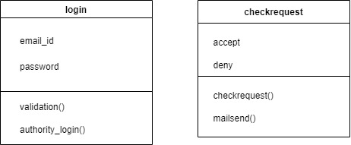

Fig 4.2.2 Authority class diagram

4.2.2 Class Diagram of Admin

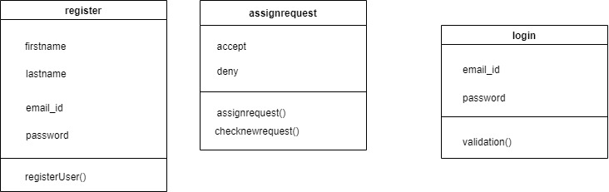

Fig 4.2.2 Class Diagram of Admin

* 1. **Conceptual Level Activity Diagram**

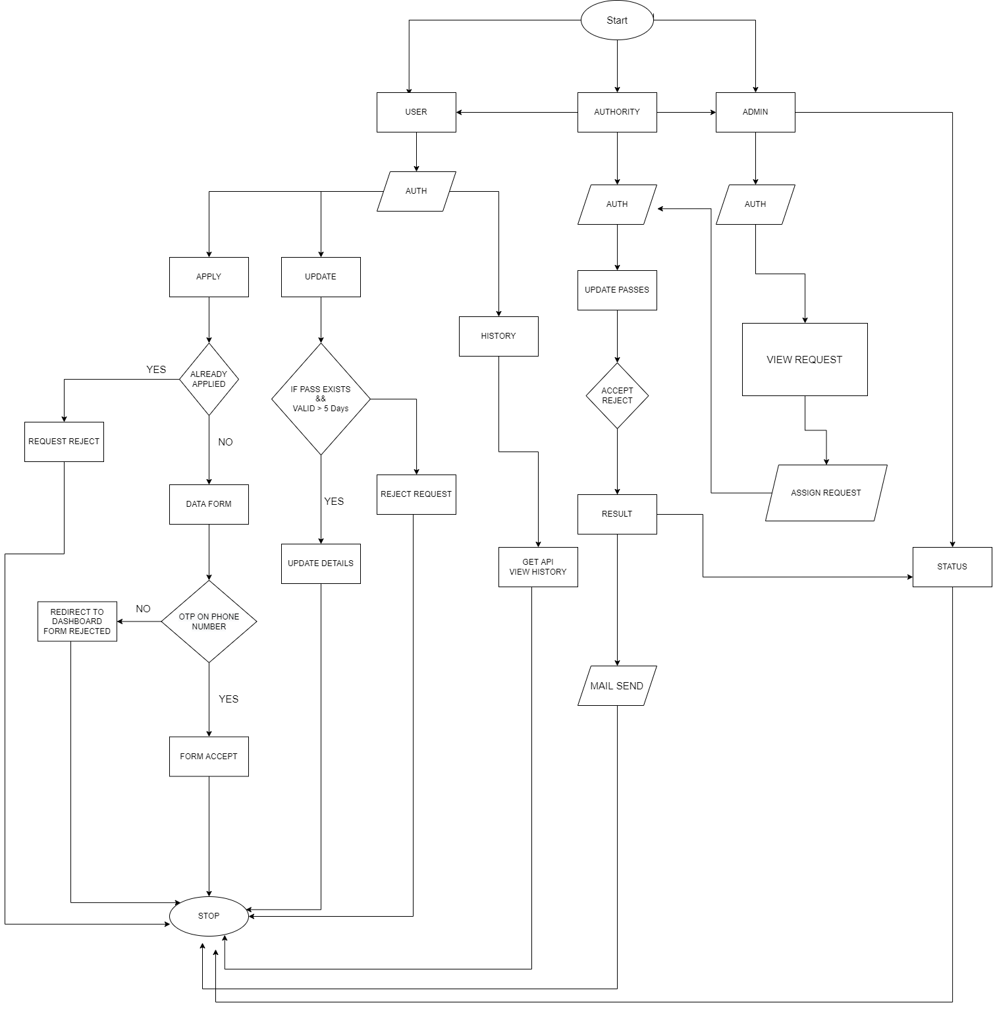

Fig 4.3 Conceptional Level Activity Diagram

* 1. **Data Flow Diagram (level 0,1,2)**

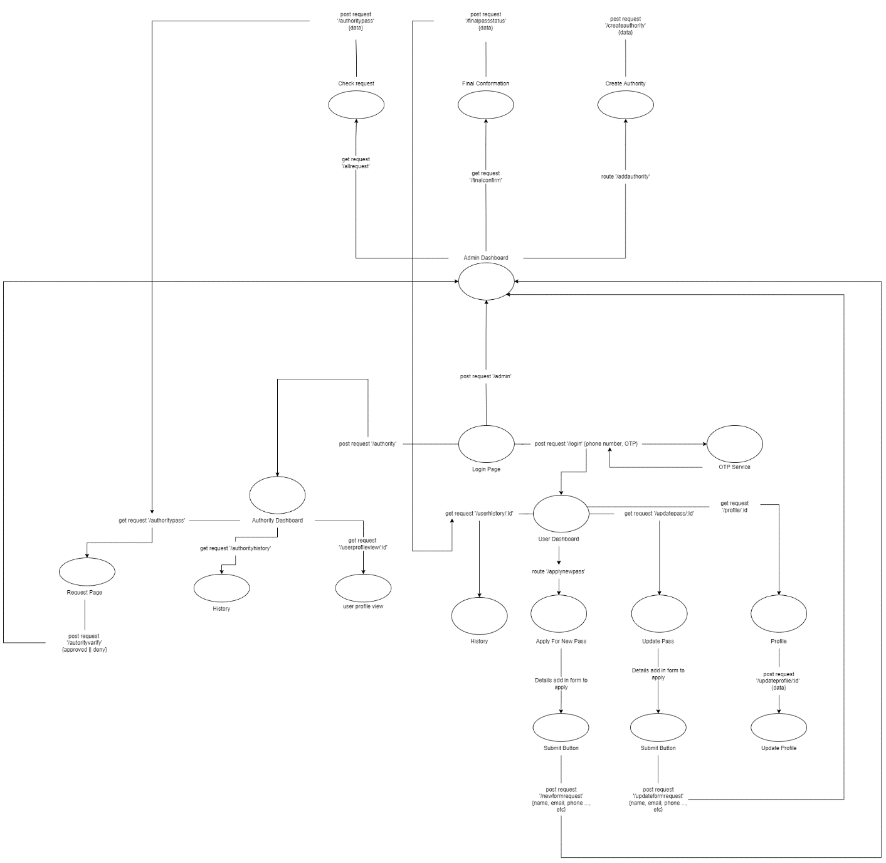

Fig 4.4 Data Flow Diagram (level 0,1,2)

**CHAPTER-5: SYSTEM MODELLING**

* 1. **Detailed Class Diagram**

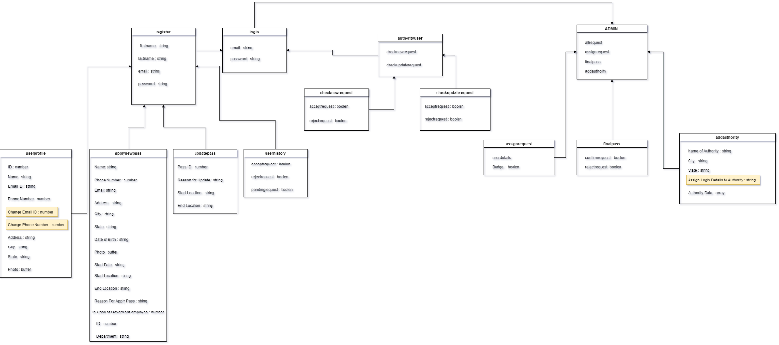

Fig 5.1 Detailed Class Diagram

* 1. **Admin Class Diagram**

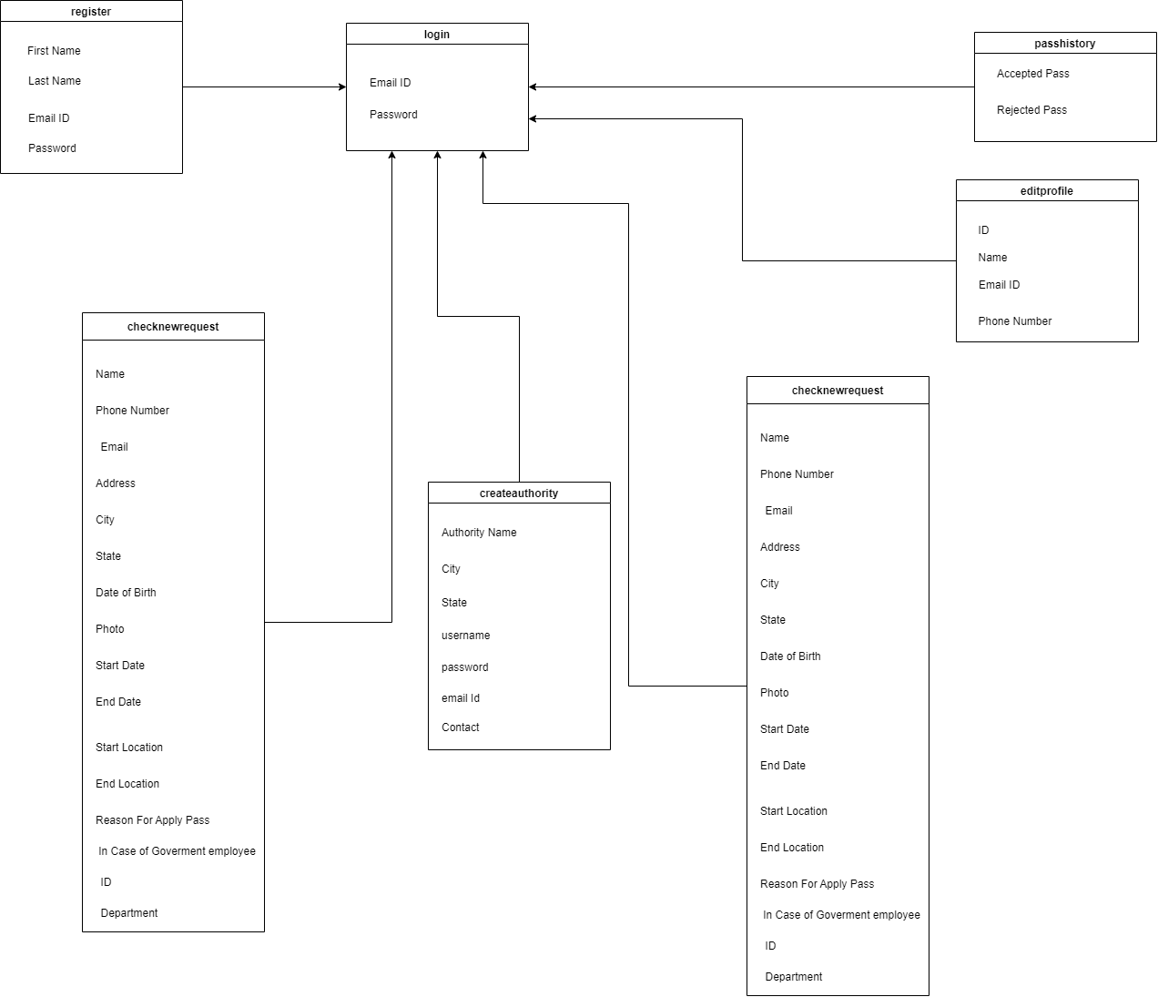

Fig 5.2 Admin Class Diagram

* 1. **Interaction Diagram**
     1. **Sequence Diagram User**

Fig 5.3.1 Sequence Diagram User

* + 1. **Sequence Diagram Authority**

Fig 5.3.2 Sequence Diagram Authority

* + 1. **Sequence Diagram Admin**

Fig 5.3.3 Sequence Diagram Admin

* 1. **Activity Diagram**



Fig 5.4 Activity Diagram